Introduction:

Respected Sir,
This is our project report of our tuition registration and management system. In this report We are try to that how to make this project? With step-by-step procedures. Here We are very exiting to design this project report because this is our first project report so every step is new for us. But our project guide give us full instructions for design this project & project report.
In this project report we are include all steps to design this project. These steps are Objectives, Environment and Tools used for design this project, Analysis and design documents, Outputs of project, Limitations of the project, Future application of the project, Bibliography. Now we see in very brief all these points.

Objectives of the Project:

This project is Database Management System. The central idea of this project is to design the Registry & Management system for tuition classes. Our project guide was gave us instructions for designing this type of project. To create this project we observed our tuition class's registration system. After then, we are requesting our tuition's sir to give us all instructions about all the processes of the tuition works.

For designing this type of project, it is necessary to gather lots of information. I am designed 10 to 11 forms and create 15 reports in this project. We have used MS Access to ensure strong database storage because it is very comfortable and secure to access data by Visual-Basic tool. We have also trying to put some extra animation effects as user attraction in this project & use some advance features of Visual Basic. We must try that our project is become user comfortable and bug free. This project is to be designed for windows environment so any users who know working with Microsoft Windows base environment can easily use this project.

Tools/Platforms, Language to be used:

Platform: -
In this project, we have using Microsoft Windows-XP Operating System as a platform. It is very comfortable for working with database management systems. This Operating system is more user-friendly then other operating systems. It supports different types of programming languages & programming development tools very well. Windows XP includes tools that help your computer run faster than Windows 98 without adding new hardware. Windows XP includes a suite of programs designed to optimize your computer’s efficiency, especially when used together. Windows XP makes your computer easier to use, with new and enhanced features. Windows XP improves computer reliability by introducing new wizards, utilities, and resources that help keep your system running smoothly. Backup provides improved backup and restore capabilities, including support for more tape drives and the latest hardware. It’s now easier for you to preserve your valuable data. You can back up files from your hard drive to floppy disks, a tape drive, or another computer on your network. If your original files are damaged or lost, you can restore them from the backup.
In our project, We have using MS Access as a backend so Windows-XP is more comfortable then any other operating systems.

Tools & Language: -

- In our project, we have using Visual Basic for designing different type of forms.

- In Visual Basic, we can easily design graphical-user system and makes easy connection with database.

- In our project, we have using Visual Basic’s ADODB Control module to call data
- For animation, effect we have using Timer Control of Visual Basic. By use of this Control, our form screens looks very attractive.

- we have also use Data Grid Control for showing input data in output forms.

- For creating reports, we have using Data Report facility where we first create Data Environment then set it’s property after then add commands and then show Report as output of the project.

- At some place we have using query instead of tables in order to get advance out-put results.

- We have using forth generation programming language for coding because it is easy in understanding and writing.

Analysis & Design Document

In this project we create Input-Forms by visual basic and using these forms enter different student related data like Roll-No, Name, Address, Phone-No, any type of tuition classes or student related information.
First, we have introducing main forms of our project.

- Student's Detail:
- By using this form, we can enter many data related to students as shown in above figure.

- In this form, we have put finding-record technique by entering by the Roll No, Name, surname, etc.. of the students.
- We have applying some user comfortable steps in this form for entering data.

- This is main form of this project because in this form, we store all student related information at the time of admission in the tuition. Thus, this form is called Student's Detail.

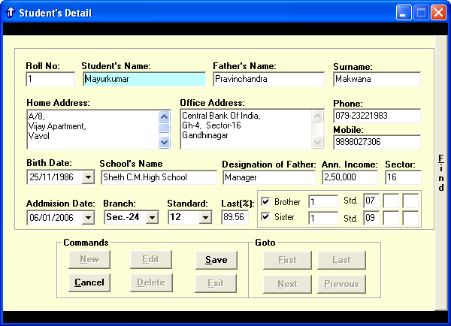

- Attendance Form:

- This is Attendance details form.

- In this form, we can enter student’s attendance either absent or present.

- From this form we can make a report of attendance of student easily.

- Using this technique, we can enter one or more student’s attendance at a time because we have list of roll number and also get other details from student's detail form.

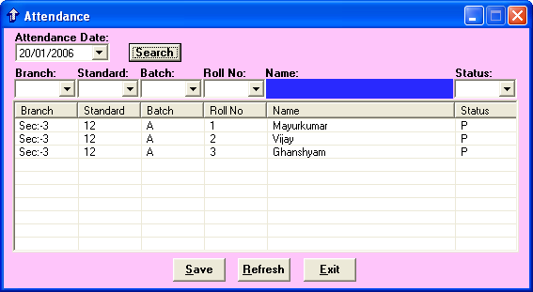

- Test & Result Form:

- This is Test & Result form .

- In this form, we can enter student’s result's details and generate report.

- With the help of this form we can get fully detail of every student & we can also put any remark about student.
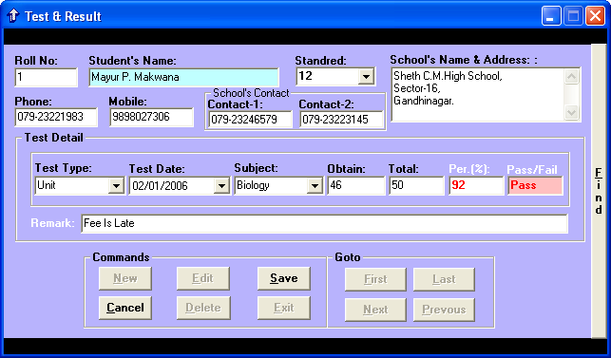

- Fees Detail Form:

- Above figure is Fees detail Form of our Project.

- This form is the multi receive fee form.

- In this form Fee* is the sum of tuition fee, material fee and other fee. While the figure under Fee* is subtraction of Fee* and total receive fee.

- In this form also MultiFinder option

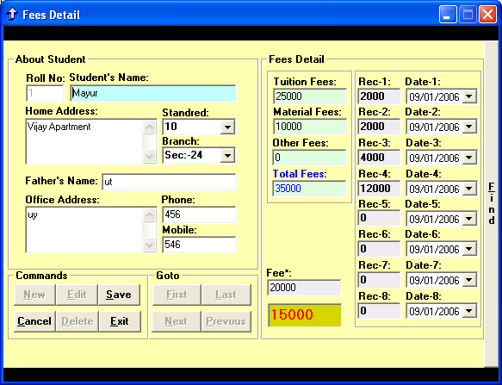

  - Reports:

- Above figure is display reports of this project.

- Using these form we can get all type of report within this project, like standard wise, sector wise, branch wise, etc..

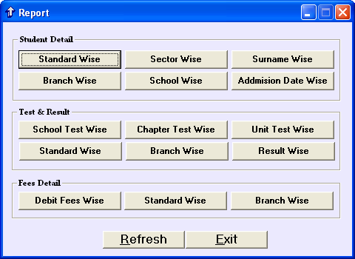

Outputs of the Project:

After completing the design of this project, we are putting here run-time forms and reports as outputs of the project.

  - Main Form:
- Above figure is display output result of main form of our project.

- At a runtime, this form is displaying after splash and login forms of this project.

- This form contains different menu items for different tasks such as Student, Attendance, Test & Result Fees etc…

- In above form you can see some animation effects like GOOD NOTE.

- GOOD NOTE means that it is depends on the current time like Good Morning, Good Noon, Good Night, etc..

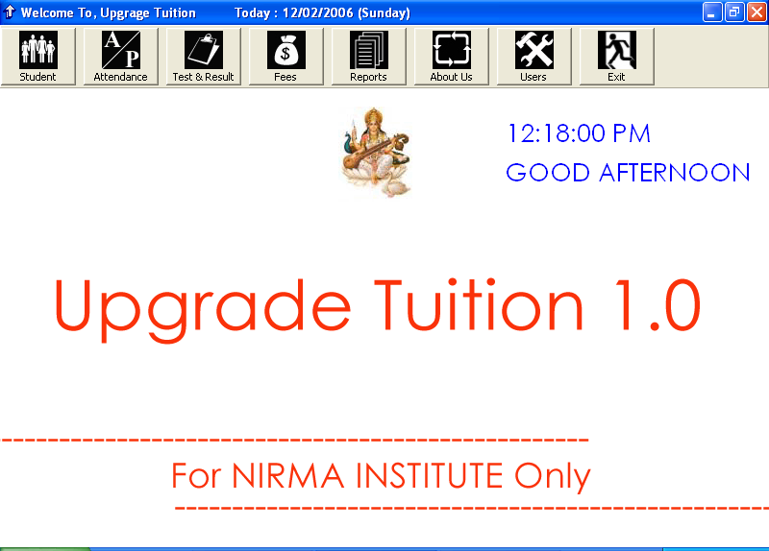
Good Note

Limitation of the project: -

In this project, we have trying that there is no any problems are face with users while it gets implemented. However, our project has some limitations because this project is specially designed for tuition classes. Some limitations of this project is…

- This project is specially designed for windows environment so this project is run with Windows-98, 2000 and Windows-XP environment.

- To run this project user must be familiar with windows operating system.

- In these project users cannot add any extra facilities on the fly.

- In this project all forms not auto updated so user must use ‘save’ command after finish entry.

- User cannot change directly in reports because all reports are auto updated if he/she wants to change must change in forms database.

- User must remember their project password because if not remember your password they cannot use this project.

Bibliography:

- Visual Basic Black Book

Respected Sir,
This is our project proposal for designing PREVOYANCE 06 and our project guide help us to design this Project proposal.

